35.50: For constructive interference:
For destructive interference: 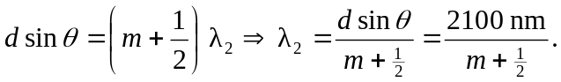
So the possible wavelengths are
Both 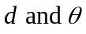 drop out of the calculation since their combination is just the path difference, which is the same for both types of light.

